# APPLIED MACHINE LEARNING

# MID-TERM PROJECT REPORT

## TOPIC: Using algorithms to build the ultimate Fantasy Premier League team

## TEAM MEMBERS:

Naishal Shah (ID: )

Yashwi Passary (ID: 2001457596)

### 1.PROBLEM STATEMENT:

FPL is a virtual football manager game where fantasy managers pick players who score points based on how well they perform in real-life.

### 2.DATASET EXPLANATION:

We got cleaned and web-scraped data from Kaggle (Link). The dataset consists of statistics for every individual player and the games they played from 2016 onwards. The dataset contains over 126,000 rows of data and over 37 columns to work with.

The columns are as follows:

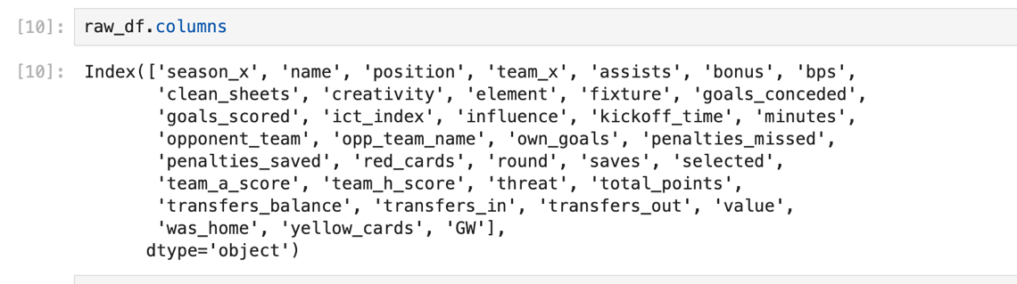

### 3.BREIF EXPLANATION OF THE GAME:

The objective of the game is to score the most points. Points are scored through goals, assists, clean sheets and saves. Points are deducted when a player receives a yellow card, red card or scores an own goal. Players are priced according to their points potential. Logically, higher the price, higher the perceived points potential. For example, Erling Haaland is priced at £14.0m, while someone like Elliot Anderson is priced at £4.5m.

Rules:

1. You have a £100.0m budget to pick a squad of exactly 15 players (2 goalies, 5 defenders, 5 midfielders and 3 forwards.)
2. From your squad of 15 players, you must choose 11 playing players and 4 to sit on the bench. Of these 11 playing players, there must be exactly 1 goalie, at least 3 defenders, at least 2 midfielders and at least 1 forward. Points scored by players on the bench do not count towards your team’s total.
3. You cannot pick the same player more than once and cannot have more than 3 players from the same team.
4. Each week, you must decide a captain, which earns you double the points for that player for that week. You are also eligible to make one free transfer within your team each week, with every additional transfer setting you back 4 points.

4.TARGET ACHIEVED: Effort your team has made so far and any preliminary result.

here are the constraints for the optimization model:

* Pick players that maximize total predicted points
* Exclude players that are no longer playing in the premier league, those that are injured or suspended, and any player who is highly likely to be a rotation risk.
* Pick exactly 11 players. The reason why I want the model to suggest 11 playing players is because it becomes complicated when the concept of a bench is introduced.
* Pick exactly 1 goalie, a minimum of 3 and maximum of 5 defenders, a minimum of 2 and maximum of 5 midfielders, and a minimum of 1 and maximum of 3 forwards.
* Pick a maximum of 3 players from any given team
* Do not exceed a budget of £83.0m (since we are picking 11 and not 15 players, and I prefer to have a bench that does not exceed £17.0m).
* Spend at least £82.0m (As I do not like to have a lot of money in the bank. This only applies to FPL and not real life. If you would like to send me money, please feel free).

5.FUTURE PLAN: Briefly state your plan for the rest of the semester on the project.

* **Incorporate New Player Data:** By incorporating data on incoming players from foreign leagues and assigning appropriate weights, the model could make more comprehensive player selections.
* **Utilize Advanced Metrics:**By integrating advanced metrics like expected goals (xG), expected assists (xA), and player involvement in critical events, the model would have deeper insights into player performance.
* **Address Injuries and Suspensions:** Factoring in player injuries and suspensions would be the model to avoid players who might miss upcoming matches and thereby enhance overall team performance.
* **Dynamic Data Integration:** Enabling the model to adapt to changing circumstances by incorporating dynamic features like player prices and recent form would improve both short and long-term decision-making capabilities.

### 6.REFERENCES: